**AGM Report for Support and Outreach**

**Katia Dolan BSW (she, her, they)**

**June 2024 – March 2025**

|  |
| --- |
| **I respectfully and gratefully acknowledge my relationship with the ancestral land of**  **unceded territories that are home to the Ktunaxa, Sinixt, and Syilx Nations. I honour the**  **First Nations, Inuit and Métis peoples who also dwell on this land where I live, work and create.** |

The last year for me was filled with supporting people individually to apply for housing and social assistance, connecting people with medical services and providing aids to survive (food, blankets, tents, clothing etc.) in extreme, changeable weather conditions. With an upstream approach, I attended community interagency meetings, facilitated education tables, co-presented harm reduction to a class of teenage students, supported ANKORS students and participated in PAN Organizational Stigma research. To further inform my practice I took advantage of a number online educations offered by PAN. Overall, feeling success for the community members I work with and interagency team collaboration enhances my gratitude for the work I do.

Opportunities for affordable housing in Nelson have improved throughout the last year. I attended monthly meetings of the **Coordinated Access Supported Housing** (CASH) table. This table comprises of a range of local service providers including BC Housing, who collaborate to identify those community members in greatest need. We discuss the circumstances for those who could be a suitable fit for either market housing with the **Supported Rent Supplement Program** (SRSP) or the newly opened North Shore Inn (NSI) facility. I also attended a re-activated **Coordinated Housing Access Team** (CHAT) where we work from a ‘By Name List’ to hopefully house people in the coming months and years. I supported individuals to complete relevant application forms including the **Vulnerable Assessment Tool (VAT)** for the above, and advocated for them at the monthly meetings. As a team we are pleased to have about 38 community members housed.

With a team approach I have helped community members to apply for social assistance: **Person with Disabilities** (PWD) and **Person with Persistent and Multiple Barriers** (PPMB). These applications require much needed personal detail and commitment from the applicants themselves to focus on their contribution. MSDPR approval for PPMB can come in a single day.

For both housing **VATs** and **PWD** applications the approach has to be trauma informed and location of meeting flexibility is necessary. Meet people where they are at, without rancour or judgement can make all the difference. For some people, if we weren’t willing to go to a remote location and sit on a log filling in required information, the PWD application would not get done. Transportation can be a barrier; physical/mental disabilities, sparse bus services, and isolation intersect to immobilize access to social determinants of health. A gentle, sensitive, self-aware approach is important all round, to maintain a safe and non-triggering environment. Community members have opened up to me as a stranger–a success I am grateful for.

Both **PWDs** and **VATs** don’t really exemplify people’s strengths. Strengths tend to be down played in vulnerability assessments. Their strengths and the rhetoric required for equitable treatment, though not inaccurate, is purely focused on weakness in order to qualify for housing/ financial supports. This can be challenging when practicing from my strength based practice perspective! To compensate I counter this by acknowledging the strengths they have and I do see.

The Street Outreach Nurse-Nelson Cat MacLean and I marked **World AIDS Day and International Indigenous Awareness Week** by offering information, pizza, music and a relaxing atmosphere (see photo). We were situated in the basement of ANKORS and normally for this event, we would offer HIV testing but the HIV nurse was away. We considered our presentation a success based on the interest in the information presented and the ambiance created by those who attended.

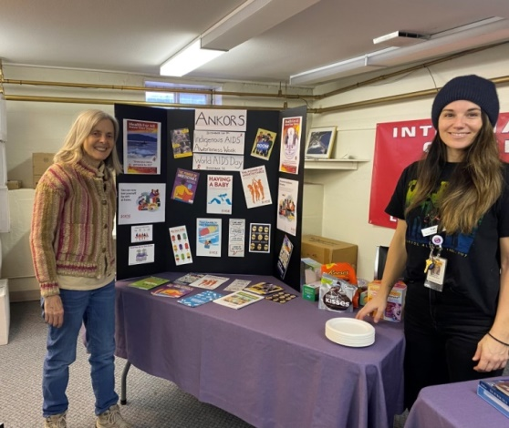

Katia & Cat

**World AIDS Day & International AIDS Awareness Week at ANKORS**

I also have helped support two **practicum students**. I made myself readily available to provide aspects of my social work role at ANKORS. One was a BSW U Vic student and the other a Masters level student with City University, who is doing just a portion of their practicum with ANKORS. I love this aspect of my work as the experience of meeting both these students has reinforced my knowledge, and offered rewarding connection. I have also invited a **doctor**, a **MSDPR Specialized Intake Worker** and **COINS personnel** to use my office to improve access to those services for community members.

The June 2024-March 2025 year was filled by supporting individual community members with needs and goals for health and wellbeing in a patient step by step, fits and bursts approach that, though mildly frustrating at times, marks the kind of support and outreach work that I am available and happy to provide. My work was also sprinkled with community collaboration that broadens my view and helps me experience a little bigger perspective plus a sense of collaboration that fuels my persistence to maintain a solid course for my work.

My **Upstream Work** included:

* Community Action Team (CAT) meetings for Nelson/Castlegar and Grand Forks,
* Nelson Committee on Homelessness (NCOH)
* NPD EDI Advisory Committee to put together *Religious and Cultural Guidebook*
* Castlegar Integrated Services Collaborative
* Homelessness Summit Working Group
* PAN Organizational Stigma research.

**Harm Reduction Education Tables:**

* Hepatitis Day July 28th at ANKORS
* Castlegar Community Connect Day
* International Overdose Awareness Day, Castlegar (aft) and Nelson (eve).
* World AIDS DAY Dec 1st with Nelson Street Nurse Cat* (see photograph)

**My** **Education**

-Through PAN:

* PAN Building Blocks for Hepatitis & Sexual Health Literacy
* Building Team Strength from the Ground Up
* Concept Mapping
* HIV & Aging
* Concept Mapping

-Also:

* First Aid
* Disabilities in Workplace, Violence & Harassment in the Workplace, WHMIS
* REDUN Mtg. with PIVOT Legal re. Homeless Encampment

**The End**